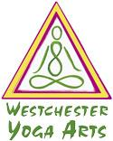
Westchester Yoga Arts RYT -300 Yoga Teacher Training Application

Please print this form, and return completed form in a sealed envelope, marked ATT: Wendy, Laura, Kristina, and Dina to:
Westchester Yoga Arts, 49 Lawton Street, New Rochelle, NY 10801

Name:

Address:

Phone:

Email:

How long have you been doing Yoga:

When, and from where did you receive your RYT200 certification, or when will you finish your certification:

Do you have concerns about the course?:

What teacher has inspired you and why?:

What Inspires become a Yoga Trainer?:

What is your favorite book?:

What is your favourite song ?:

What is your favourite movie ?:

