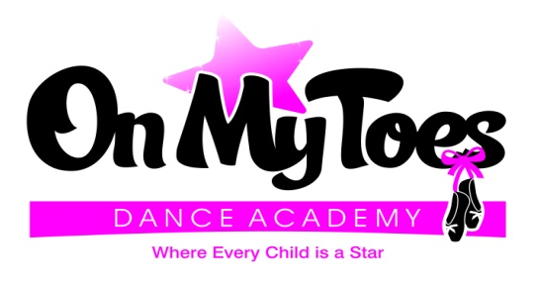

3565 Crompond Road
Cortlandt Manor, NY 10567
914-734-2838

2018 Summer Camp Schedule

On My Toes is so excited to be offering these amazing Summer Camps this year! Our camps will be exciting educational camps where your child will experience art of dance in a fun-filled environment! The only thing you have to do is pack your child a peanut-free snack and drink and drop them off for tons of fun!

Session I: Princess & Pirates Tumble Camp - Ages 3 to 5 year olds
Week of August 6 - 10 from 9am – 12noon
Taught By: Miss Cynthia
Children will begin to learn the fundamentals of dance and tumble in a creative way! Each day there will be different adventures for your child to experience such as a treasure hunt, arts and crafts, games and more!

Session II: Circus Camp – Ages 3 - 5 year olds
Week of August 13 - 17 from 9am – 12noon
Taught By: Miss Cassie
Children will learn simple acrobatic tricks, circus stunts and dance tricks. We will focus on coordination and balancing skills while working through obstacle courses and have a ton of circus fun!

Session III: X-treme Dance Camp – Ages 6 – 9 years old
Week of August 20 – 24 from 9am – 12noon
Taught By: Miss Cynthia
Each day a different type of dance will be introduced and taught. The students will experiences the differences of Tap, Jazz, Hip Hop, and Lyrical in a fun and safe environment! Each day will be a new adventure in the art of dance.

Each week is only $99 – Register by June 15th and receive $10 off!!!

2018 Summer Camp Registration

Student’s Name: _______________________________________________________

Student’s Birth Date: ________/________/________ Age: _________________

Street Address: __________________________________________________________________

City: _________________________________ State: _____________ Zip: ________________

Home Telephone Number: _____________________________________
Email Address: _______________________________________________

Mother’s Name: ________________________________ Cell # ______________________________
Father’s Name: ________________________________ Cell # ______________________________

Emergency Contact: _______________________________ Phone Number: ____________________

Please check off which session your child will be participating in:

[ ] Session I – Princess & Pirates Tumble Camp Ages 3 – 5
Week of August 6 – 10 9am – 12 noon

[ ] Session II – Circus Camp Ages 3 – 5
Week of August 13 -17 9am – 12 noon

[ ] Session III – X-treme Dance Camp Ages 6 – 9
Week of August 20 – 24 9am – 12 noon

If there is anything special we need to know about your child (i.e. allergies, medical conditions, etc.)

In consideration of being granted permission to take dance lessons or any other program offered at On My Toes, Inc., I do hereby remiss, release, and forever discharge the instructors and On My Toes, Inc., and its students, trustees, agents, officers, servants, and employees of and from any and all liability, claims, demands, actions, and causes of action whatsoever, arising out of and from any and all liability, claims, demands, actions, and causes of action whatsoever, arising out of or relating to any loss, damage, or injury including death, that may be sustained by the undersigned and/or my child, while in, or on, or under the premises of On My Toes, Inc. or any other premises leased to or under control or supervision of On My Toes, Inc. The undersigned, being duly aware of the risks and hazards inherent in practicing dance, hereby elects voluntarily assumes all risks, loss, damage or injury, including death, that may be sustained by the undersigned, or to any executor and administrators of each of the undersigned. In signing the foregoing release, the undersigned hereby acknowledges and represents that he/she has read the foregoing release, understands it, and signs it voluntary.
*I further give permission to use any photo or video for promotional or clerical use.

Parent’s Signature: ________________________________________ Date: ________________________

